<https://youtu.be/NMV1847ODb8>

Create a dossier = dashboard

Use **Duplicate as Metric to convert attribute to metric**

Sometime convert metric to attribute if metric can’t be sorted

Move report – open your report – left corner save as

Freeze top row – right corner – More Option

Same Chapter is using the same data source, then allow you create many pages

One filter will affect all page under the same charter, if you want filter only apply on 1 chart, click the right hand corner of each box, the 3 dots. Add new qualification.

============= add entire page filter



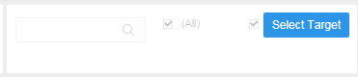 hit the chart. Table

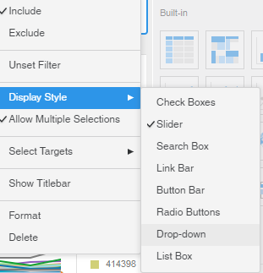

Right click---select Target---click any cell----SELECT---any cell---Apply

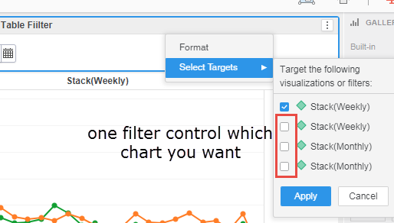

Add color to a table, click Format

color based on cell value -- Formatting conditional values on a grid: Thresholds

MS support dual x axis , e.g. month above year at the bottom, but very hard to use mouse to drag it to the right position

If the date u choose for filter can’t show calendar style, coz you using a aggregated date, e.g. weekly

How to refresh dataset ============================================

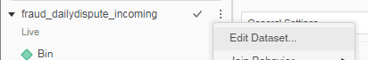

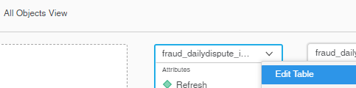

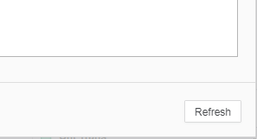

How to row totals microstrategy dossier============================

Way 1:

1.Drag creditRating to Column Box

2.right click the Email, Duplicate as Metric 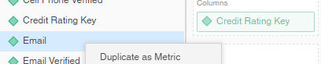

3. drag Sum(Email) to Rows Box

4. 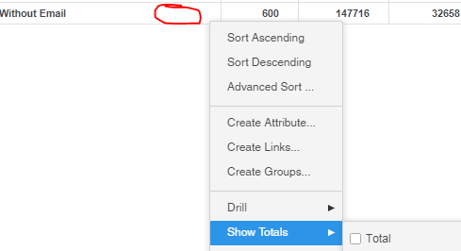

<https://www2.microstrategy.com/producthelp/current/HRAM/WebHelp/Lang_1033/Content/Adding_Subtotals.htm>

How to column totals microstrategy dossier============================

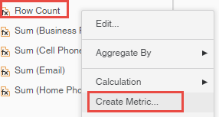

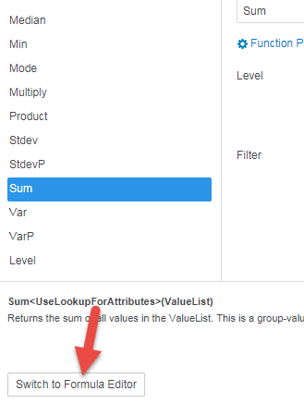

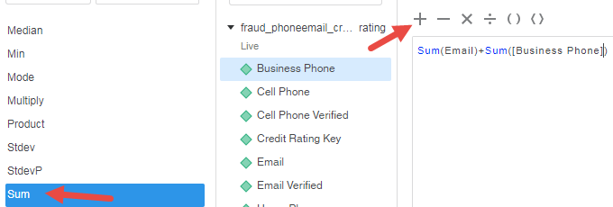

=====================how to add two axis duel axis or create two lines from two column in one chart

Drap the below chart’s line to the top chart, if you want to color it, drag the Grey **Metric Name** from **Break by** to Color

==================== how to let MS read integer as a metric?

Usually a column with integer will be read as an attribute, if u want to use it as metric, have to duplicate it as metric, but it come with a SUM function for it, which is stupid , it can’t be used as a regular metric.

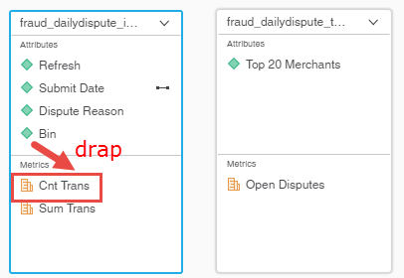

============================if you put the date on the top, only two options, can’t do it at the bottom

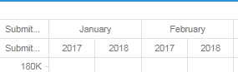

Or

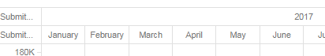

==================reduce repeated column name

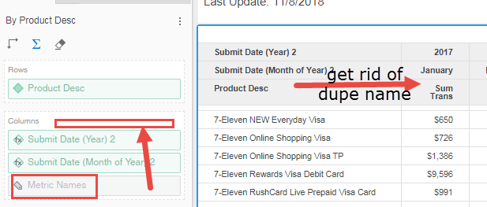

================merge column

Right corner--- more option --- Merge, and Lock=freeze column

===================date to create month

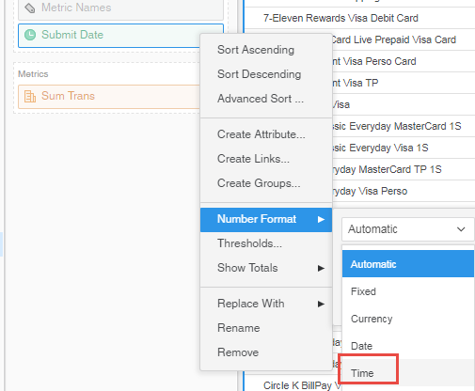

===================group by date to month and year

Right click date – create attribute—select monthend Function

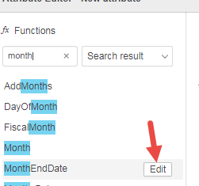then select the date as object

============= change axis position from side to top?

Right click the axis,---format

Hide

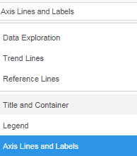

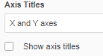

Then use chart title to show relevant information

===================Two conditions in IF statement

You can’t put metric and attribute in the IF …AND logic, can only put two attributes

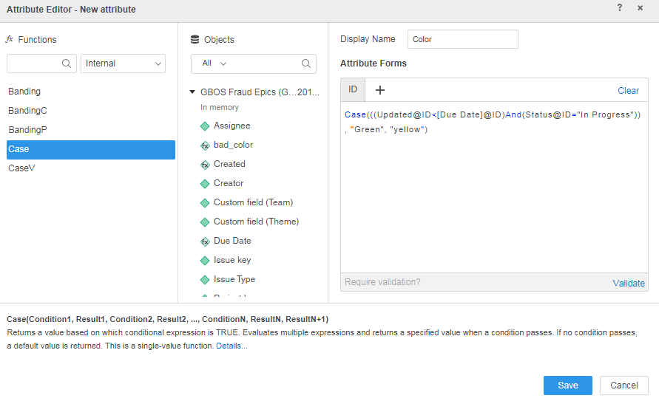

You can put a case inside case, you can <https://www2.microstrategy.com/producthelp/10.9/FunctionsRef/Content/FuncRef/Case_functions.htm>

This example generates a report where if the revenue, represented by the Total Revenue metric, is less than 300,000, the function returns a 0; if the revenue is less than 600,000, the function returns a 1; if revenue is any other value, the function returns a 2. The case metric is defined as follows:

Case(([Total Revenue] < 300000), 0, ([Total Revenue] < 600000), 1, 2)

Case(((today@ID>[Due Date]@ID)And(Status@ID="Done")), "Late", ((today@ID>[Due Date]@ID)And(Status@ID="In Progress")), "Done", "In Progress")